KYRIAKOS ELEFTHERIOU 11012506, ANGELOS KYRIAKOUDIS

Abstract

This is an assignment is about the mobile phone communication systems. In the following report, we explain the coding and modulation techniques of the current and emerging technologies of the mobile communication systems

COMMUNICATIONS ASSIGNMENT

Section D, Mobile phone communication systems

# Old- Current and Emerging Technologies of Mobile Communication Systems

|  |  |
| --- | --- |
| Mobile Phone Communication Systems | |
| **1G** | Wireless Telephone Technology |
| **2G** | GSM |
| **2.5G** | EDGE |
| **3G** | UMTS (Universal Mobile Telecommunications Systems) |
| **3.5G** | HSDPA (high Speed Downlink Packet Access) |
| **Evolved HSPA** |  |
| **4G** | LTE (Long-Term Evolution) |
|  | WiMAX |
|  | LTE Advanced |
| **5G** | Tactile Internet |

|  |  |
| --- | --- |
| Wi-Fi Generations | |
| 1997 | **802.11** |
| 1999 | **802.11 a** |
| 1999 | **802.11 b** |
| 2003 | **802.11 g** |
| 2009 | **802.11 n** |
| 2013 | **802.11 ac** |
| 2012 | **802.11 ad** |

# What is Coding and Modulation?

Modulation and Coding provide the means of mapping information transmitted into waveforms so when they are transmitted, a demodulator and decoder can recover the information that was send at the first place. (Appropriate demodulator and decoder)

One of the simplest model is the white Gaussian noise. Modulation is the process of converting a signal (that may be voice, video, speech etc.) to a modulated form, enabling it to be sent over a long distance, without the need of wires (in the case of mobile communication). Modulation is generally compromised of 3 categories, being amplitude modulation, frequency modulation, and phase modulation. The most important goal of any communication system is to transmit error-free data. Two basics coding that needs to achieve the goal of communications systems are source coding and channel coding. The main concept source coding is the translation of the real words into digital and for the channel coding is to keep the signals error free and eliminate the noise.

Table of Contents

Old- Current and Emerging Technologies of Mobile Communication Systems 1

What is Coding and Modulation? 1

Aims and Objectives 3

Existing and new Generation Analysis 4

EDGE 2.75G 4

UMTS 3G 4

HSDPA 3.5G 4

HSPA + 3.5G 5

LTE 4G 5

Tactile Internet 5G 5

Modulation Comparison Table 6

Wi-Fi Generations 6

IEEE 802.11 6

IEEE 802.11ac 7

IEEE 802.11n 7

IEEE 802.11ad 7

802.11 Wi-Fi Modulation Techniques 8

Modulation Techniques 9

Quadrature phase shift keying (QPSK) 9

Minimum-Shift keying Modulation 9

Gaussian MSK 9

Phase shift keying 10

8-PSK 10

QAM (Quadrature Amplitude Modulation) 11

In General 11

QAM Graphs 12

Link Adaptation 13

Coding in mobile communication systems 13

Source Coding 13

Channel Coding 14

Communication System- Generation 14

Coding Technique 14

Convolutional Coding 14

Block Coding 14

Turbo Coding 14

LDPC Coding 14

Convolutional Coding 14

Block Coding 14

Turbo Coding 15

LDPC Coding 15

Cyclic redundancy checking 16

Hybrid Automatic Repeat Request H-ARQ 16

Parity checking 16

Conclusion 17

Bibliography 18

# Aims and Objectives

* Study and Learn about Modulation
* Study and learn about coding
* Understand the error-detecting coding
* Research about old-current-and emerging mobile communication systems
* Research about Wi-Fi communication systems
* Understand constellation diagrams

There are many aims and objectives on this coursework. It is important to understand the relationship of the Modulation and coding with the speed and stability that they can offer to communication systems. It is important to understand how error detecting codes are working, to be able to deal with noise and other problems that may arise while working on a communication projects.

First of all, wireless communication is transferring data and information over a distance without the need or use of wires/cables. That distance may be short – for Wi-Fi connection – or larger, where mobile communications are needed. There are many devices capable of using wireless communications, such as mobile phones, radios, laptops, PCs etc.

In the past few decades, or more specifically, in the past decade, mobile communication systems have improved dramatically, and each improvement was named as a generation, which actually specifies the speed of data transmission.

# Existing and new Generation Analysis

## EDGE 2.75G

This is a digital mobile phone communication system which has many enhancements over 2 and 2.5G. It is a technology that works with GSM antennas. It enables the transfer of data clear and fast. It was invented in USA by the company today known as AT&T.

Channel coding contains: Outer block coding, Inner convolutional and interleaving scheme for error bursts. A faster version of GSM. It is actually a 3G technology which was built on improving the GSM. The speeds of it upped to 384 kbps. It enabled the transfer of delivery of multimedia and other applications to mobile phones devices.

## UMTS 3G

This generation enabled the operators to offer great speeds and advanced services, which included video calls, wireless internet data and wider voice telephony. It was then, that GPS devices made their breakthrough to the market. In full it is named Universal Mobile Telecommunication System. It is the system that it is currently used in UK when we do not have signal and access to HSDPA or the newly LTE. In theory the UMTS can reach transfer rates at 42 Mbit/s.

It is a packet-based transmission of data which can be text, voice, video and. In Europe, the bands used are 2100 MHz and in USA 850 and 1900 MHz

Furthermore, the channel coding used contains forward error correction, Turbo coding and convolutional coding with block interleaving

Coding for UMTS contains: Forward error correction, cyclic redundancy check, Convolutional inner coder, Reed Solomon outer, Service specific Turbo, Unequal repetition and Puncturing coder.

Modulation - demodulation: QPSK, BPSK, RAKE RECEIVER.

## HSDPA 3.5G

What is HSDPA? In short HSDPA means High Speed Downlink Packet access. This is nowadays well known as 3.5 G, as it emerged after the 3G (3rd generation) as an evolution of it. It is an enhanced version of the third generation. Furthermore it is based on UMTS and as of 2013 it can support down-link speeds up to 8-10 Mbit/s. This was a smooth evolution to UMTS technology. It is intended and was made to be able to provide similar down-link – download speeds with the ADSL which is mostly used in homes and it is a cabled network.

The HSDPA uses a coding and modulation technique which is changed depending on the user. It also depends on the quality of the signal and the cell usage. The techniques used are usually the QPSK (quadrature phase shift keying, which offers speeds around 2 mbit/s. If the signal and radio conditions are good, then 16 and 64QAM is used which significantly increases the speed of the down-link, which is about double the QPSK.

## HSPA + 3.5G

Stands for High speed Packet Access. It is the most widely deployed mobile communications broadband in the world. This mobile broadband technology is actually a combination of HSDPA and HSUPA technology when both of those are deployed on a network. The maximum download speed is 168 Mbit/s.

## LTE 4G

Stands for Long-Term Evolution. It is the successor of the 3rd generation UMTS. It is actually an update of it. Although, it is not backward compatible with 3rd gen. Furthermore, it does provide significant increase in speed in data transmission in comparison with its predecessor. Theoretically it can support speeds at 300 Mbit/s. It has become available to UK very recently, although countries like Sweden and Norway had it before 5 years. The spectrums available in UK are 800MHz, 1800 MHz and 2.6GHz. The difference between the three spectrums, is that the 2.6 GHz is that it has a greater data capacity, although it does not travel in long distances. The higher the frequency, the more data sent but less distance traveled. There are many expectations at this stage from this generation. High video streaming and high quality audio are key.

Features: Low data transfer latency

Increased spectrum range/flexibility

Architecture is simplified

Very high speed on data transfer

## Tactile Internet 5G

This is the name that is used on most research papers found until now. It is the next major phase of evolution. 5th generation will have very powerful features never seen before. It is not yet on any device and there is no actual release date. After some research, it was found that this technology will use an all new technique for modulation, which the results that are claimed by the makers are outstanding and quite unbelievable at the moment! Furthermore, it is said that the modulation technique used will be named WAM. The only information available for this it is that the modulation scheme will use spectral compression which improves spectral density. WAM stands for wave modulation. Makers reckon that they created a modulation scheme that offers significantly bigger and higher spectral density, and it is backwards compatible with previous generations.

Company supports the following for WAM modulation

* Easy design
* Low cost
* Major speed increase
* Very good noise tolerance
* 50% spectrum savings
* 50% lower power usage
* Up to 400% the distance of QAM
* 10dB Gain Advantage

Those claims are really exciting if they really are true, but unfortunately the company has yet disclosed any other information regarding how the modulation scheme works, or any other detail.

# Modulation Comparison Table

|  |  |  |
| --- | --- | --- |
| **Gen.** | **Communication System** | **Modulation Technique used** |
| **2G**  **2.5 G** | GSM  GPRS | GMSK  GMSK |
| **2.75G** | EDGE | 8PSK |
|  | CDMA 2000 | QPSK |
| **3G** | UMTS | QPSK |
| **3.5G** | HSDPA | QPSK  16QAM  Adaptive Modulation (signal dependence) |
| **3.5G** | HSPA | 64QAM |
| **3.5G** | HSPA + | 64 QAM |
| **4G** | LTE | QPSK,16QAM,64QAM |
|  | WiMAX (for sake of comparison) | QPSK,64QAM,16QAM |

# Wi-Fi Generations

IEEE 802.11, is a wireless networking standard, which uses many and multiple antennas so it can increase the data rate. The 802.11 protocol, uses a Half-duplex over the air modulation, which provides communication to both ends, but only 1 end can transmit data at a single time. Improvements were made over the time, to increase the speed transfer of data, and it was accomplished through the years with many techniques and by changing the modulation.

Nowadays the protocol 802.11 is used for Wi-Fi connections. Furthermore, historically, we can understand the age and the release date of each protocol by the letter that follows. For example, June 1999, 802.11 – a, was used. At September 1999, the protocol 802.11-b was used. Similarly, through the years, the generations were: 802.11 -1, 802.11 –b, 802.11 –g, 802.11 –n, and recently, from 2013 802.11 –ac is getting used.

## IEEE 802.11ac

This is the latest networking standard that is adapted from 2013. Speeds of 500 megabits per second were accomplished while using the protocol. Furthermore, this was accomplished by higher density modulation of 256 QAM, and wider RF bandwidth Faster transmission than 802.11 n. Theoretically in an ideal world, it could reach speeds of up to 1.3 Gigabit per second.(To reach that speed, you need 3 data streams simultaneously). 5GHz is the only frequency band that is used. Furthermore, it is backward compatible with the previous generations

## IEEE 802.11n

This is the protocol that is available from 2009, and many devices do actually use it at the moment. Furthermore, the improvement from the previous generation was accomplished by using Multiple input multiple output antennas. It does support 2.4 GHz and 5GHz, and the data speed limit is ranging between 54-600Mbit/s

## IEEE 802.11ad

This is a very new approach and new design of this specific protocol. It does used a very high frequency never seen before on a Wi-Fi device. It is said that it does use 60GHz for transmission. It does support speeds up to 7Gbps, only for a beginning! By using techniques already used in previous generations, speeds of 100Gbps are achievable. It does have the same speed with 802.11ac, while 802.11ac uses 256 QAM modulation, while 802.11ad uses 64 QAM. Furthermore, if the modulation technique is changed, then the speed will be greater. The technology for it is very new and it needs time for the engineers to be able to use it to the maximum, but it is really exciting seeing the possibilities.

Different modulation techniques and data range comparison on 802.11n. It can be clearly seen that by changing the modulation, different speeds are achieved.

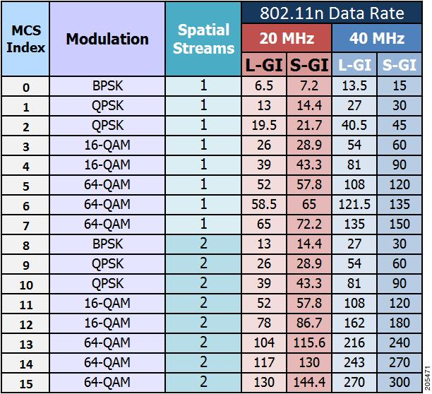

REF:http://www.cisco.com/c/dam/en/us/td/i/200001-300000/200001-210000/205001-206000/205471.tif/_jcr_content/renditions/205471.jpg

|  |  |  |
| --- | --- | --- |
| 802.11 Wi-Fi Modulation Techniques | | |
| **Protocol** | **Modulation** | **Frequency** |
| 802.11 a | 64 QAM | 5 GHz |
| 802.11 b | 11 CCK | 2.4 GHz |
| 802.11 g | 64 QAM | 2.4 GHz |
| 802.11 n | 64 QAM | 2.4GHz AND 5GHz |
| 802.11 ac | 256 QAM | 5GHz |

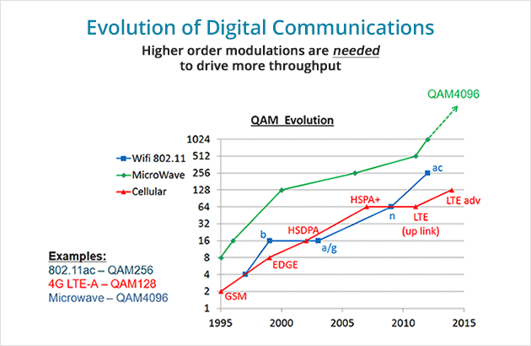

REF:http://www.magna-com.com/wp-content/uploads/2013/12/graph-evolution1.gif

Very interesting graph concerning the evolution and technologies with modulation techniques used

# Modulation Techniques

As people try always to improve, speed is a very important aspect for that improvement. Furthermore, people always rush to find solutions which lead to other problems, and modulation is a very good example. As said, there are many techniques were engineers try to send a lot of data to increase the speed. Until today, QAM amplitude and phase modulation can get as long as 256 states. However, as we try to increase the bits, the SNR signal to noise ratio gets such a bad value, which can destroy the information. To avoid that, we use bigger amplifiers, which mean bigger power and we end up with very high distortion. So, at the moment, even technology has its limitations, until another innovation comes out.

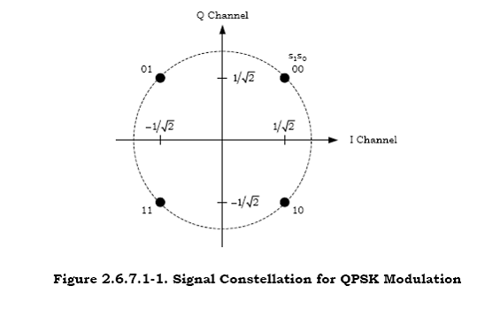

## Quadrature phase shift keying (QPSK)

A form of Phase Shift Keying. There are four possible carrier shifts, which are placed at 0, 90,180 and 270 degrees (or 45, 135, 225 and 315 degrees) . Two bits are modulated at a single time. First letter of QPSK (Q) stands for quadrature, which essentially means 4 spaces. It uses 4 phase states to code two bits. (PSK with 4 states).

It is used in satellite transmission for cable modems, video conference, HSDPA mobile telecommunication and transmission of videos.

Ref : http://ecee.colorado.edu/~ecen4242/UMB/modulate_files/image004.gif

## Minimum-Shift keying Modulation

A form of modulation used in a variety of digital communication systems, although old enough. Each bit is encoded as a half sinusoid. Generally, in MSK modulation, when the bit is 1 then the output is 2pi sinewave, if it is a 0, the output is 1pi bigger (3pi). So 0s and 1s differ only by a period.

### Gaussian MSK

Similar to MSK. First the data are passed and shaped within a Gaussian Filter before applied to the modulation frequency. It has high spectral density, but general needs high power to transmit data (while comparing to other type). The advantages of this modulation may be the improved spectral density when compared to PSK. Furthermore, GMSK can be amplified and remain undistorted by a non-linear amplifier (which is more efficient id DC inputs)

## Phase shift keying

It is particularly used for digital forms of radio communications and applications. PSK modulates a signal by changing the angle to 180 degrees, when there is a change from 0 to 1 or 1 to 0. PSK modulation conveys data by changing the phase, whenever a different than the current state is.

BPSK: 0 and 180 degrees are used (which are opposite) and the signal is broken down to bits. The state of the preceding bit determines the state of the current bit. So, if the phase of the wave changes angle (from 0 to 180 or opposite) the signal state changes (from 0 to 1 or 1 to 0). Furthermore, if the wave does not change, then the signal state remains the same. It can also be called ‘biphase modulation’

MPSK (MPSK): Here, there are more than two phases. Usually they are 4 (0,90,-90 and 180 degrees), or even 8 which the φ will be (0, 45, 90, 135, -45, -90 and -135).

If the phases are 4, then the MPSK is called quadrature phase shift keying, and at each phase shift, the signal elements will be 2.

Similarly, if the phases are 8, it is called octal phase shift keying, and at each phase shift, the signal elements will be 3.

MPSK with m=8

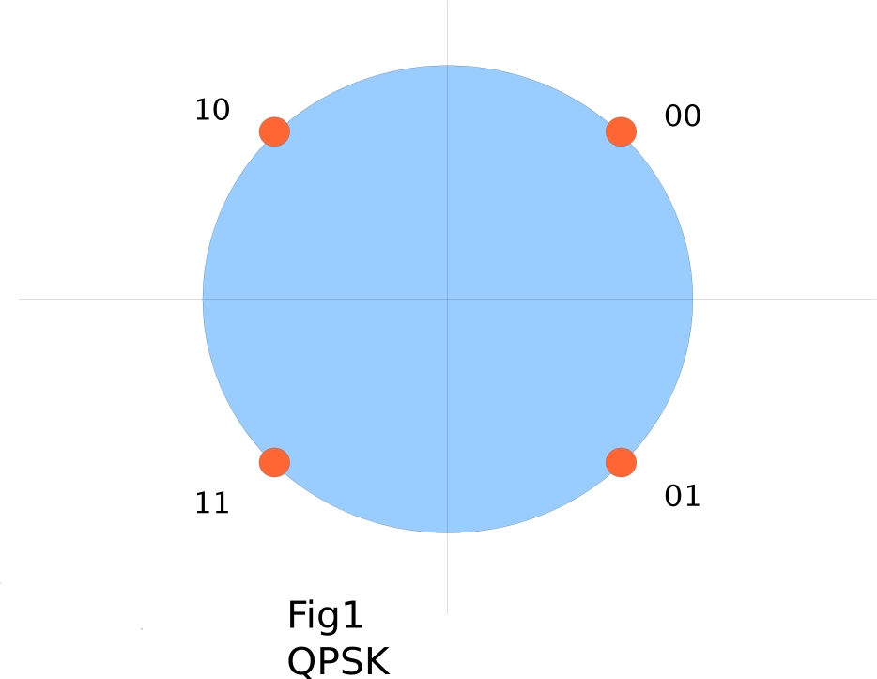

REF:http://www.linuxtv.org/wiki/images/4/43/Qpsk.jpg

QPSK

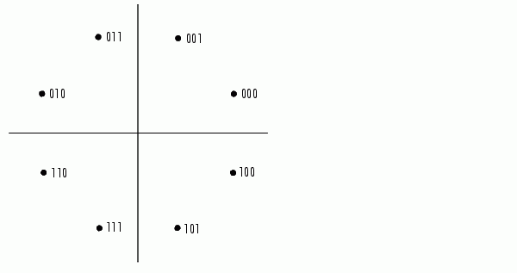

Ref:http://www-rohan.sdsu.edu/doc/matlab/toolbox/commblks/ref/simre144.gif

## 8-PSK

8 PSK is another form of phase modulation, based on PSK. That means, changing the angle each time the input bit changes state. Furthermore, ‘8’ PSK refers to the number of states (8 states). This is twice the number of states of QPSK and half of the states of 16-PSK. It is able to encode 3 bits per second due to the number of states (23). It does provide more capacity than QPSK but can tolerate noise with higher difficulty

## QAM (Quadrature Amplitude Modulation)

Probably the most important type of modulation in terms of adoption. QAM can be an analog or digital modulation. QAM conveys two signals together, modulating the amplitudes of those two with a difference of 90 degrees. The modulated signals then are summed up to a single modulated wave. QAM modulation nowadays is very important, and most of the most recent mobile phone devices do use this technique for modulation. Furthermore, as the technology evolves and as new generation of mobile system comes up, it seems that the engineers were using this technique to send more bits every time. So by the first QAM modulation that we could sent 2 bits, they were newer techniques for sending 16 QAM, 64QAM etc., which essentially is sending more bit/s. The generations evolved from QAM to 16QAM, 64QAM, until the newest 256 QAM used in LTE technology (4G). Although there is a limit while trying to do this, so that’s why it was not managed yet to send let’s say 1024 QAM. Furthermore, as we increase the number of bits, the noise gets higher and higher, and the output is really bad. To overcome this amplifiers are needed, power need goes up, and we end up with a lot of distortion.

QAM available versions are 16QAM, 64QAM, 256QAM, and recently they are trying to make 1024QAM and 4026QAM, with microwave signals, but the technology didn’t reach there yet. There is a great need to reduce somehow the noise. And it is tricky, for the reason being that SNR=(signal power/noise power), and Noise=(n*Bandwidth). Shannon’s law states that C=B*log2(1+S/N). With this equation we find that, if we want to increase the bandwidth, to send more data, the noise gets greater, and destroys the information. There is a need to find a way to bypass the noise.

# In General

It is generally understood that there are 3 techniques of modulation, which every modulation technique is based on. Phase modulation, Amplitude modulation and frequency modulation have to be well studied in order to understand the basic principles for any other modulation. It is quite clear that PSK uses phase modulation. Furthermore, everything that is based on PSK (MPSK, 8-PSK, 16-PSK etc.) is using this technique.

Furthermore ASK uses amplitude modulation and varies the amplitude.

In that order, FSK uses frequency modulation varying the frequency

Furthermore, it is understood that the digital modulation techniques available are clearly based on analogue modulation techniques.

The only one that is not based on analogue modulation is QAM, for the reason being that it does have its own version of analogue modulation.

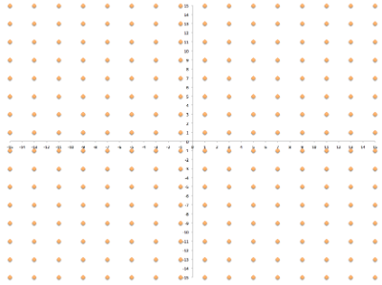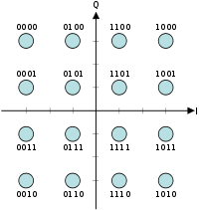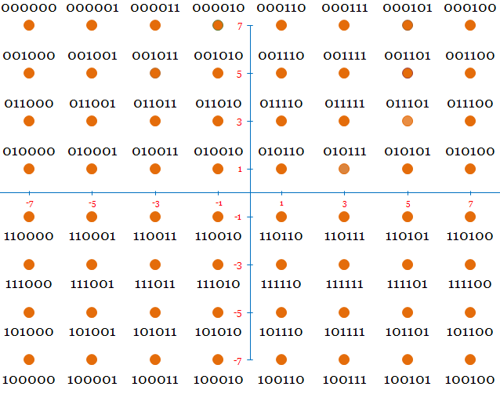

## QAM Graphs

Here we can see 3 constellation diagrams of the differences of QAM. Furthermore, it is to be seen, the differences of number of bits that each one of those can have. It is clear that the 64 QAM can have significant more data than the 16 QAM, but significantly less than 256 QAM.

It is also clear, that the denser the data sent, the easier noise will be able to destroy the information.

So if there is a little noise, 16QAM will have a lot easier work to demodulate the data than 256QAM, so much more errors can be made while denser the spectrum.

Furthermore, the more sophisticated the code has to be, to be able to handle more noise and so less errors.

On the below diagram, we can see clearly the effect of noise on the signal, after the amplification, and how it can destroy the information.

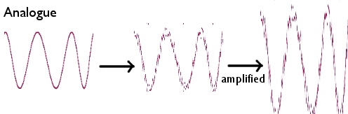

REF: http://scienceaid.co.uk/physics/waves/images/digana.png

256QAM REF:http://community.arubanetworks.com/t5/image/serverpage/image-id/5989i949D111F8A24EEE9/image-size/medium?v=mpbl-1&px=-1

16 QAM REF:http://upload.wikimedia.org/wikipedia/commons/thumb/1/1e/16QAM_Gray_Coded.svg/200px-16QAM_Gray_Coded.svg.png

64 QAM REF:http://www.gaussianwaves.com/gaussianwaves/wp-content/uploads/2012/10/64QAM-constellation.png

## Link Adaptation

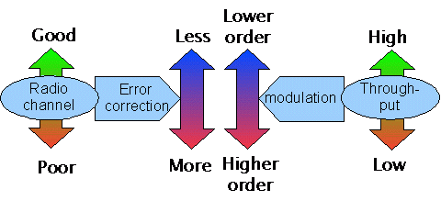What does Link adaptation stand for? It is a term that is used in radio communication. It is very important for the reason that it is the ability to adapt on a modulation scheme, and the coding error – rate correction. Furthermore, it refers to a set of techniques, where coding rate and modulation are changed to suit and adjust to the channel condition that is changed. With link adaptation we select the best suited coding scheme to the specific channel.

Ref: http://www.telecomabc.com/l/link-adaptation.html

# Coding in mobile communication systems

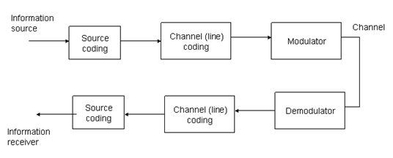

Figure 1 Communication system block diagram (from Proakis and Salehi, page 8)

## Source Coding

Source coding is the procedure of translation of real words into digital signals. The best way to explain what is source coding is one example. Suppose we have the word “Coding” and will send it out. Before doing that translation is needed to turn it into bits (‘0’ and ‘1’). If we use ASCII code to translate it, we will get back,

01000011, 01101111, 01100100, 01101001, 01101110, 01100111

The above 7-bit code is the word “Coding”.

In this particular case ASCII code was used to translate the word “coding” which used a fixed length of the code, but in reality because the probabilities to have the same code for different words are high the better solution is to use different method of translation with no fix length of code.

## Channel Coding

The channel coding is a framework that helps to increase the reliability of information of transmission, with the cost of the reduction in information rate. This is achieved by creating redundancy with transmitted data in order to decrease the loss during the time of transmission. The importance of this procedure is very big in mobile communication industry because it helps to reduce errors in transmission.

Due to the channel noise we have problems like the exceeding data traffic, data loss and maximum transmission interferences. For this reason in mobile communication it is compulsory to use this technique to face the problems. Except from mobile communications systems we can find this technique generally in wireless communications networks.

In these days there are many channel coding techniques for communication systems and to select which we will use depends type of communication and the standards of it about the data transmission.

|  |  |
| --- | --- |
| Communication System- Generation | Coding Technique |
| **GSM** | Convolutional Coding |
| **WCDMA** |
| **GPRS (3G)** | Block Coding |
| **EDGE (3G)** |
| **UTRAN (3G)** |
| **CDM2000** | Turbo Coding |
| **UMTS 3G** |
| **LTE (4G)** | LDPC Coding |
| **E-UTRA (4G)** |

## Convolutional Coding

This is a type of error correcting code

The most common and widely used technique in mobile communication systems and some other wireless communications is the Convolutional Coding. In this technique has the encoding of number of bits. These bits are the smallest units of data and have information about current or recently data values that transmitted inside the transmitted data. The reason for these transmitted values is to inform the receiver about the features and size of the transmitted data. These data helps receiver to check the bits of the transmitted information for any loss or path corruption, in addition it makes sure that the data that we received are the same as the data that we sent.

The most popular mobile communication standards which using Convolutional Coding Technique are**GSM** and **WCDMA**

# Block Coding

One other common used coding technique in mobile communications is Block Coding. This technique encodes a fixed number of code bits inside of transmitted data values to protect the data and correct any error. The number of code bits which encoded categorized by the number of bits transmitted per second from the sender, and one other important is that the transmitted data remains fixed.

Block Coding commonly used in combination of Convolutional coding technique in **3G GSM** networks, including **GPRS**, **EDGE** and **UTRAN** systems.

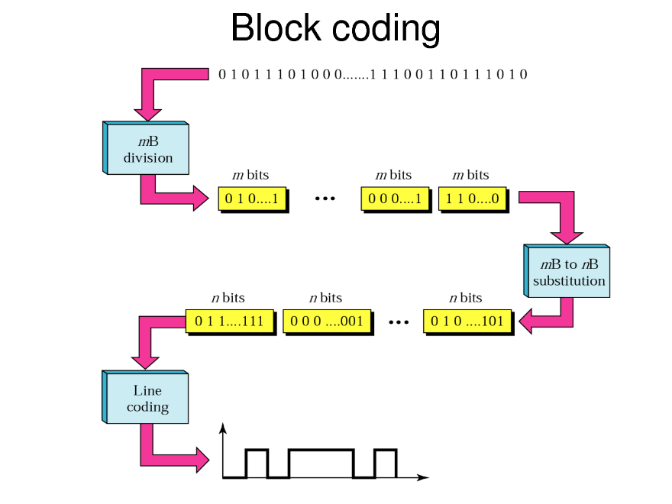

Figure 1REF: http://img.docstoccdn.com/thumb/orig/127015698.png

# Turbo Coding

Turbo Coding technique uses encoding data bits as interleaved code symbols at sender, which help the receiver to make the error checking. The procedure on this technique is to employ randomly error control bits between two encoders, which generate distinct error checking codes together with transmitted bits of data. This method make the process of data encoding at the sender’s end faster, and helps the very fast decoding and enhanced error reduction at the receiver. This kind of techniques mainly used for very long range communication networks like satellites but some mobile communication systems use it too.

Turbo coding with combination with Convolutional coding has been used on the **CDM2000**, UMTS, LTE. Turbo coding is finding use nowadays in many communication systems such as 3G and 4G due to the very good performance of it.

# LDPC Coding

LDPC Coding technique used to give error protection to data from many noise sources in the path of transmission. The mechanism of this technique employs the foundation to set the maximum limit of noise interference with data signals inside the transmission. LDPC achieve the maximum value for noise included data bits to define the noise threshold levels inside data values of transmission by encoded parity bits.

OFDM (Orthogonal frequency-division multiplexing) is a method of encoding digital data on multiple carrier frequencies. It uses LDPC Coding technique to protect the transmission data from noise. 4G mobile networks like **LTE** and **E-UTRA** use the OFDM transmission method.

## Cyclic redundancy checking

Cyclic redundancy checking is an error detection coding. It is mainly used in digital networks and storage devices like SSD drives, and it is responsible for detecting accidental changes in data. It is a method for checking the errors that may exist while transferring data, due to noise or other issues making errors in coding. It is a 16 or 32 bit division of data, with the result of a cyclic redundancy code

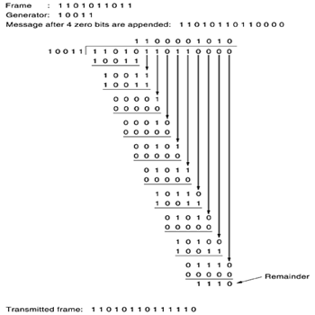

REF:http://images.devshed.com/af/stories/0Yeti/Cyclic_Redundancy_Check_html_1f09126e.png

It is a simple division between the data and the generator, to find the remainder. The remainder number is being sent on the receiver, were a recalculation is made. If then the remainders do not match, then there is an error and corruption in code.

## Hybrid Automatic Repeat Request H-ARQ

Used in 3.5G HSDPA, HSUPA and HSPA+, H-ARQ is a combination of the two FEC and ARQ error control. It uses parity checking. It is quite challenging to understand how this works. Firstly, prior to transmission of the signal, it adds FEC and ED into the message signal. When sent, the decoder checks the error-correction code. If the quality of the channel is good then then the errors can be corrected, else, it is requested from the transmission to resend the same data.

## Parity checking

Parity checking was mainly used between GSM and GPRS, second generation communications. How does parity checking work? Well, before data gets transmitted, it counts the number of bits, and specifies if it is even or odd number. At the receiving end, after receiving the data, it is checking again if the data are odd or even. In case they are different from the beginning, then it realizes that there is an error.

# Conclusion

To conclude our report, there are a few things worth mentioning. First of all, it was quite a challenging work to be done from us, while being only two group members instead of 4, as advised by the lecturer, for the reason being that there weren’t any other available members. Time management was a key, while trying to complete this report.

This project was quite difficult and challenging to be made, for the reason being the lack of knowledge on the specific task of mobile phone communication systems. Countless hours of studying specific books had to be made, to enable us to provide enough knowledge for this report. Furthermore, the online sources available, are very inaccurate most of the times, making it even more difficult.

We had to overcome those difficulties, but they were really worth it. Studying about modulation and coding techniques, really solved many questions we had for a couple of years, not knowing were to search for. It is important to understand how modulation and coding techniques, can really improve dramatically a device download of information speeds, without even a need to touch the hardware.

It is to be noted, that while researching for this specific task, we learned a lot better our module, due to seeing many diagrams, graphs and due to the need of understanding.

It is worth also noting that we realised the big problem that noise can cause to any communication system. Due to that, noise destroys information, engineers had to overcome this problem by providing solutions with error coding. It is very interesting seeing how this improvements enabled the higher and denser sending and transmitting of spectrum, while minimising the damages of noise.

Learning how to make constellation diagrams was really interesting, and also completing all our aims we had from the first place was something very important.

The coding in the mobile communication systems is the main factor to achieve the transmission of error-free data from the sender to the receiver. In one system the coding is used before modulator and after demodulator. In the first case the source coding translate the real words into digital data and the channel coding has to transfer these data without error by using the techniques that we analysed in the report. The second case that the system uses coding is after demodulator to make the checks of errors and correct them, finally translate the digital data to the real words.

Last, but not least, we would like to highlight the knowledge we acquired through this research. It is really worth mentioning how we really learn throughout this whole process of researching and writing this report.

# Bibliography

* *4G and LTE: everything you need to know*. 4G and LTE: everything you need to know. Available at: http://www.techradar.com/news/phone-and-communications/mobile-phones/4g-and-lte-everything-you-need-to-know-926835 (Accessed: 2 January 2015).
* Clark, G. and Cain, B. (1981) *Error-correction coding for digital communications*. 1st edn. United States: Kluwer Academic/Plenum Publishers.
* *CRC*. Available at: http://www.webopedia.com/TERM/C/CRC.html (Accessed: 2 January 2015).
* ‘Duplex (telecommunications)’ (2015) *Wikipedia*. Wikipedia. Available at: http://en.wikipedia.org/wiki/Duplex_(telecommunications)#HALF-DUPLEX (Accessed: 20 January 2015).
* ‘Error detection and correction’ (2015) *Wikipedia*. Wikipedia. Available at: http://en.wikipedia.org/wiki/Error_detection_and_correction#Error-correcting_codes (Accessed: 5 January 2015).
* ‘Evolved HSPA’ (2014) *Wikipedia*. Wikipedia. Available at: http://en.wikipedia.org/wiki/Evolved_HSPA (Accessed: 18 January 2015).
* *Gigabit Wi-Fi: 802.11ac is here: Five things you need to know* (no date). Gigabit Wi-Fi: 802.11ac is here: Five things you need to know | ZDNet. Available at: http://www.zdnet.com/article/gigabit-wi-fi-802-11ac-is-here-five-things-you-need-to-know/ (Accessed: 20 January 2015).
* *Glossary Definition for QPSK* (no date). Glossary Definition for QPSK. Available at: http://www.maximintegrated.com/en/glossary/definitions.mvp/term/QPSK/gpk/244 (Accessed: 18 January 2015).
* ‘High-Speed Downlink Packet Access’ (2014) *Wikipedia*. Wikipedia. Available at: http://en.wikipedia.org/wiki/High-Speed_Downlink_Packet_Access (Accessed: 18 January 2015).
* *Hybrid Automatic-Repeat-request Systems for Cooperative Wireless Communications* (no date). Communications Surveys & Tutorials, IEEE. Available at: http://ieeexplore.ieee.org/xpl/articleDetails.jsp?arnumber=6578867 (Accessed: 15 January 2015).
* ‘IEEE 802.11n-2009’ (2015) *Wikipedia*. Wikipedia. Available at: http://en.wikipedia.org/wiki/IEEE_802.11n-2009 (Accessed: 20 January 2015).
* ‘Link adaptation’ (2014) *Wikipedia*. Wikipedia. Available at: http://en.wikipedia.org/wiki/Link_adaptation (Accessed: 18 January 2015).
* *Link adaptation* (no date). Link adaptation - Telecom ABC. Available at: http://www.telecomabc.com/l/link-adaptation.html (Accessed: 18 January 2015).
* *LTE* (no date). What Does LTE Stand For? Available at: http://compnetworking.about.com/od/cellularinternetaccess/g/lte-broadband.htm (Accessed: 18 January 2015).
* *LTE OFDM, OFDMA SC-FDMA & Modulation* (no date). LTE Modulation | OFDM OFDMA SC-FDMA | Radio-Electronics.com. Available at: http://www.radio-electronics.com/info/cellulartelecomms/lte-long-term-evolution/lte-ofdm-ofdma-scfdma.php (Accessed: 19 January 2015).
* ‘Minimum-shift keying’ (2015) *Wikipedia*. Wikipedia. Available at: http://en.wikipedia.org/wiki/Minimum-shift_keying (Accessed: 21 January 2015).
* *New modulation scheme said to be ‘breakthrough’ in network performance* (no date). 2013-12-17T16:13-05:00. Available at: http://www.networkworld.com/article/2172787/wireless/new-modulation-scheme-said-to-be--breakthrough--in-network-performance.html (Accessed: 20 January 2015).
* *parity checking* (no date). C392FA607C4CFFB2CDBC0094C5A54042. Available at: http://www.webopedia.com/TERM/P/parity_checking.html (Accessed: 5 January 2015).
* *QAM (quadrature amplitude modulation)* (no date). QAM (quadrature amplitude modulation). Available at: http://searchnetworking.techtarget.com/definition/QAM (Accessed: 18 January 2015).
* Semenov, S., Krouk, E. and Semenov, S. (2011) *Modulation and Coding Techniques in Wireless Communications*. 1st edn, Semenov, S. and Krouk, E. (eds). United Kingdom: Wiley, John & Sons, Incorporated.
* ‘Universal Mobile Telecommunications System’ (2014) *Wikipedia*. Wikipedia. Available at: http://en.wikipedia.org/wiki/Universal_Mobile_Telecommunications_System (Accessed: 18 January 2015).
* *Universal Mobile Telecommunications System (UMTS)* (no date). Universal Mobile Telecommunications System (UMTS). Available at: http://whatis.techtarget.com/definition/Universal-Mobile-Telecommunications-System-UMTS (Accessed: 18 January 2015).
* Viterbi, A. and Omura, J. (1980) *Principles of Digital Communication and Coding*. United Kingdom: McGraw-Hill Education (ISE Editions).
* *WAM, bam, thank you QAM*. WAM, bam, thank you QAM. Available at: http://www.theregister.co.uk/2015/01/07/wam_bam_thank_you_qam/ (Accessed: 20 January 2015).
* *WAM vs QAM* (no date). Company. Available at: http://www.magna-com.com/technology/wam/ (Accessed: 20 January 2015).
* *What is EDGE? Definition of EDGE: Cell Phone Glossary* (no date). What Does EDGE Stand For? Available at: http://cellphones.about.com/od/phoneglossary/g/edge.htm (Accessed: 20 January 2015).
* *What is HSDPA?* wiseGEEK. Available at: http://www.wisegeek.org/what-is-hsdpa.htm (Accessed: 18 December 2015).
* Wilson, S. (1995) *Digital modulation and coding*. 1st edn. United States: Prentice Hall.
* Universal Mobile Telecommunication System (UMTS) - Wireless Communications - Nuntius. Available at: http://www.nuntius.com/solutions23.html (Accessed: 18 January 2015).
* http://www.wtec.org/loyola/wireless/chapter02.pdf (Accessed: 18 January 2015).
* 4G Americas. Available at: http://www.4gamericas.org/index.cfm?fuseaction=page (Accessed: 19 January 2015).
* Quadrature Phase-Shift Keying - Explained. Available at: http://telecomreseller.com/2012/08/16/quadrature-phase-shift-keying-explained/ (Accessed: 21 December 2015).